The Bronx Defenders Thanksgiving Feast

Join us for turkey, sides and delicious pies!

Thursday, November 28, 2013
360 East 161st Street
11:30am-2:30pm

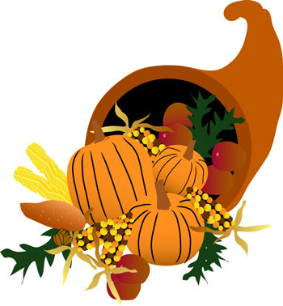

Free for clients, families, and guests
-- the more, the merrier –

RSVP Encouraged but not required.
Call Porsha: (718) 838-7878

